Nepal College of Information and Technology
Assessment 2015
Level: Bachelor |  | Full Marks: 100
Program: Civil |  | Pass Marks: 45
Course: Applied Mechanics-II |  | Time: 3 hrs
- Candidates are required to give their answers in their own words as far as practicable.
- The figures in the margin indicate full marks.
- Attempt all the questions.
1a | A 2 kg collar (Fig 1a) can slide without friction along a horizontal rod and is in equilibrium at A when it is pushed 25 mm to the right and is released from rest. The springs are undeformed when the collar is at A and the constant of each spring is 500 kN/m. Determine the maximum velocity of the collar which occurs when the collar returns to equilibrium position A. |  |  |  |  |  | [7]
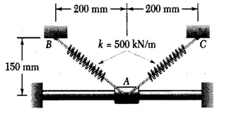  Fig 1a |  |  | 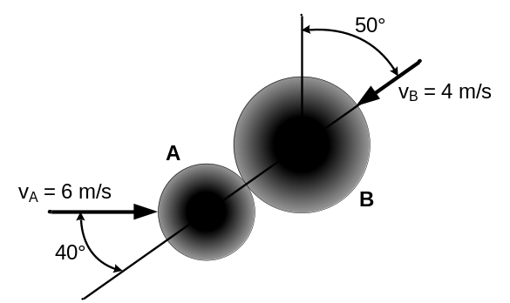  Fig 1b
1b | A 600 g ball A (Fig 1b) is moving with a velocity of magnitude of 6 m/s when it is hit as shown by a 1 kg ball B which as a velocity of magnitude 4 m/s. Knowing that the coefficient of restitution is 0.8 and assuming no friction, determine the velocity of each ball after impact. |  |  |  |  |  | [8]
2 | A system (Fig 2) consists of three identical 19.32 lb particles A, B and C. Then velocities of the particles are, respectively v_{A} = v_{A}j, v_{B} = v_{B}i, and v_{C} = v_{C}k. Knowing that the angular momentum of the system about O, expressed in flbs is H_{o} = -12k, determine (i) the velocities of the particles, (ii) the angular momentum of the system about its mass centre G. |  |  |  |  |  | [15]
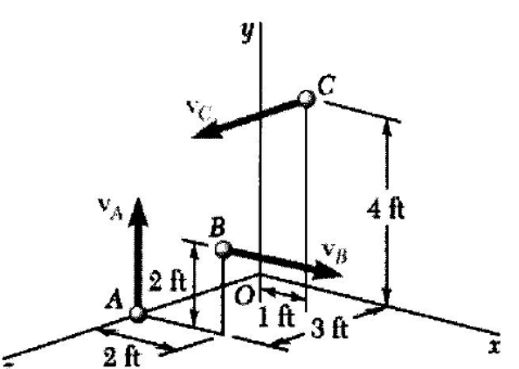  Fig 2 |  |  |  |  | 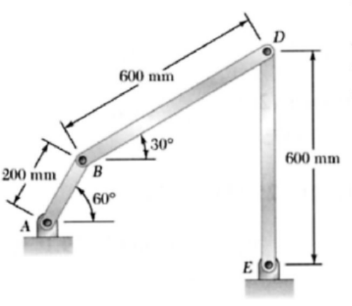  Fig 3a
3a | At the instant shown (Fig 3a) , the angular velocity of bar DE is 8 rad/s CCW. Determine (i) the angular velocity of bar BD, (ii) the angular velocity of bar AB, (iii) the velocity of the midpoint of bar BD. |  |  |  |  |  | [8]
3b | The gear reduction system (Fig 3b) consists of three gears A, B, and C. Knowing that gear A rotates CW with a constant angular velocity ω_{A} = 600 rpm, determine (i) the angular velocities of gears B and C, (ii) the accelerations of the points on gears B and C which are in contact. |  |  |  |  |  | [7]
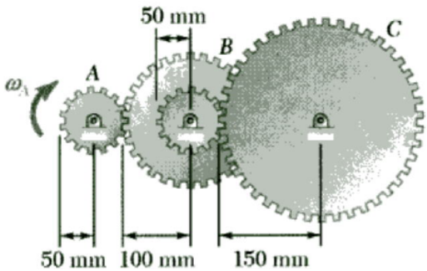  Fig 3b |  |  |  | 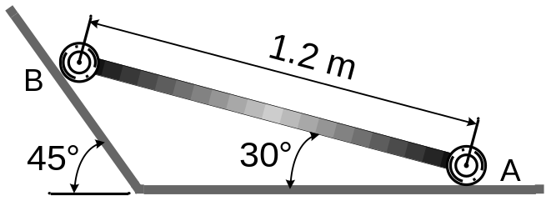  Fig 4
4 | The extremities of a 1.2 m rod weighing 25 kg can move freely and with no friction along two straight tracks as shown in Fig 4. If the rod is released with no initial velocity from the position shown, determine (i) the angular acceleration of the rod, (ii) the reactions at A and B. |  |  |  |  |  | [15]
5a | A slender 4 kg rod (Fig 5a) can rotate in a vertical plane about a pivot at B. A spring of constant k = 400 N/m and of unstretched length 150 mm is attached to the rod as shown. Knowing that the rod is released from rest in the position shown, determine its angular velocity after it has rotated through 90°. |  |  |  |  |  | [7]
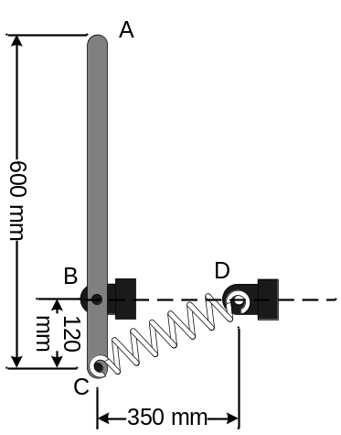  Fig 5a |  | 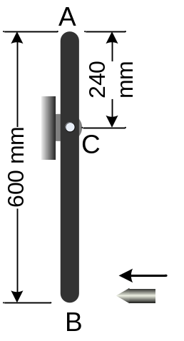  Fig 5b |  |  |  | 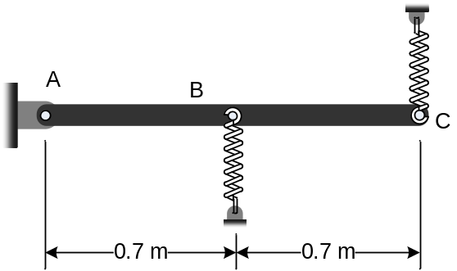  Fig 6
5b | A 40 g bullet is fired with a horizontal veclocity of 600 m/s into the lower end of a slender 7 kg bar of length 600 mm (Fig 5b). The rod is initially at rest, determine (i) the angular velocity of the bar immediately after the bullet embedded, (ii) the impulsive reaction at C, assuming that the bullet becomes embedded in 0.001 s. |  |  |  |  |  | [8]
6 | The 5 kg uniform rod AC (Fig 6) is attached to spring of constant k = 500 N/m at B k = 620 N/m at C, which can act in tension and compression. If end C of the rod is depressed slightly and released, determine (i) the frequency of vibration, (ii) the amplitude of the motion of point C, knowing that the maximum velocity of that point is 0.9 m/s. |  |  |  |  |  | [15]
7 | Write short note on (Any two 2×5)  - Types of impact  - Conservation of momentum  - Mass centre of systems of particles |  |  |  |  |  | [10]

